

School of mechanical and manufacturing engineering

**Laboratory 2: Measurement of Sound Power Levels by The Direct and The Comparison Methods**

Name: Hengcheng Zhang

Student ID: z5130844

# 1. Introducion:

The aim of the second laboratory session is to measure the sound power level of a noise source, which is an electric drill located hard surface of a semi-reverberant field. Two methods were used to correct the reverberation effects: the direct method and the comparison method. The whole experiment procedure followed the instruction of Australian Standard AS 1217.5. AS 1217 is a series of standards which set out various of methods to determine the sound power levels of machines and equipment. These documents specify the measuring requirements for different test environment. Among them, AS1217.5 is specified for the environment of outdoor or in large room, which is suitable for this experiment.

# 2. Apparatus:

The equipment used in this laboratory session is listed below.

## 2.1 Sound Level Meter (SLM): *Brüel & Kjær* Type 2250

The B&K 2250 is a compact hand-held sound level meter, which is mounted with a free field microphone on the top. It contains a preamplifier which transfers sound pressure into voltage. It has a broadband filter range from 3 Hz to 20KHz. This sound level meter is a powerful sound recorder and analyser. It is able to demonstrate the sound Level, spectrum plot and other kinds of sound parameters.

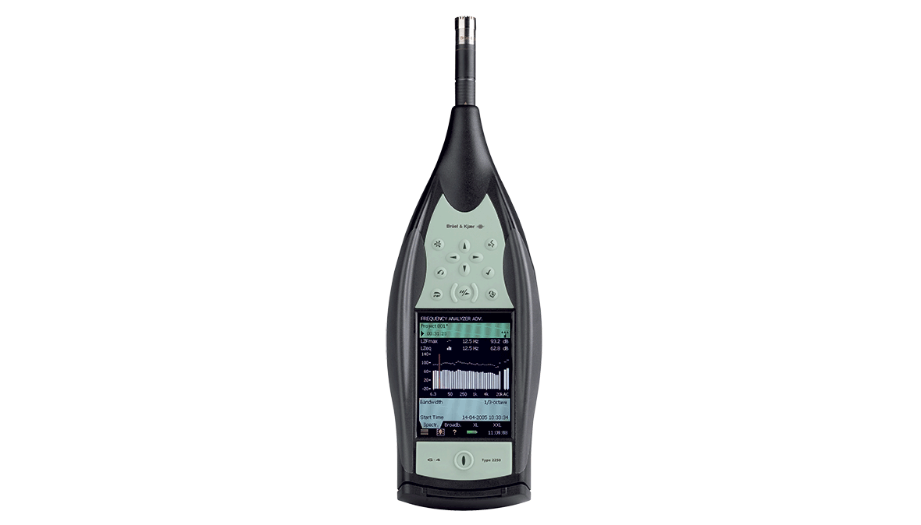

*Figure 1: B&K Type 2250 Sound Level Meter*

## 2.2 Microphone

The 4189 free-field microphone is a high-precision, high-sensitivity general purpose microphone. It is able to capture sound of frequency range from 6.3 Hz to 20k Hz with a dynamic range of 14.6 to 146 dB.

## 

*Figure 2: B&K Type 4189 Free-field Microphone*

## 2.3 Sound Level Calibrator: *Brüel & Kjær* Type 4231

The sound level calibrator generates a sound of 94 dB sound pressure level at 1000Hz when turned on. This stable sound is used to calibrate the SLM. The calibration process is easy to execute, which is shown below in the procedure part.

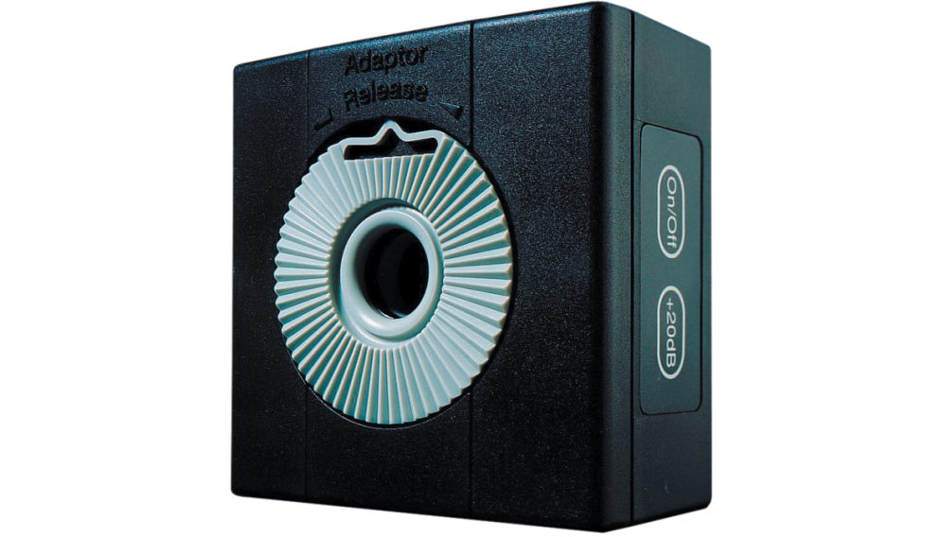

*Figure 3: B&K Type 4231 Sound Level Calibrator*

## 2.4 Makita electrical drill

This normal electrical drill was used as the noise source in this experiment

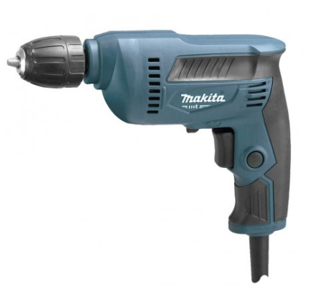

*Figure 4: Makita electrical drill*

## 2.4 B&K Reference Sound Source Type 4204

This instrument is used in the comparison method. It has been located next to the drill from the beginning while the drill was operated, is switched on and octave band sound pressure level measurements are made at the same ten locations (the drill is switched off).



*Figure 5 Reference Sound Source Type 4204*

# 3. Procedure:

As discussed in the former part, two measurement methods are performed in this experiment, the comparison method and the direct method. Both methods should follow the instruction of Australian standard AS 1217.5. So, before taking measurement, the experiment environment should be initially set up according to the standard.

## 3.1 Initial Setup

AS 1217.5 specified how this experiment is taken, including the test environment setting, the test instrumentation, operation of the source and the measurement procedure. This particular experiment is performed in a large room, which is suitable for this standard. The test locations are set up as instructed, which is a hemispherical surface and is shown below in figure 6 and table 1.

Table 1: Coordinates of Key Measurement Points

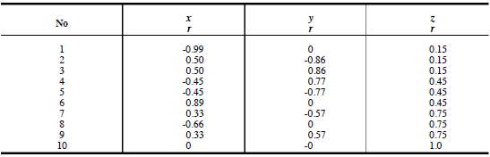

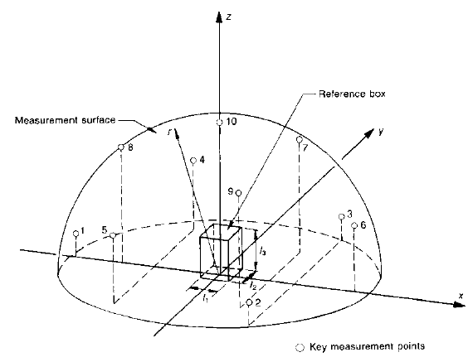

*Figure 6: Hemispherical measurement surface*

## 3.2 Calibration

In order to make sure of the accuracy of measurement result, calibration is always the first step of taking use of the sound level meter.

External calibration is utilized with a help of the 4231 calibrator in this experiment. The first step is to switch on the calibrator and the SLM, make sure the calibrator is producing sound. Then attach it to the top of the sound level meter, where the microphone is located. The next step is to click calibrate option on the screen. When this calibration is finished, remove and turn off the calibrator. The sound level shown on the screen should be 94 dB.

## 3.3 Measurement of Comparison Method

The measurement layout is shown in figure 6 and table 1. The positions are marked by white tape on the laboratory floor around the noise source.

For comparison method, the B&K reference noise source was placed at the centre of the measurement hemisphere, which is shown as reference box in figure 6.

Then turn on the reference source and start to take measurement at each of the 10 positions. During the measurement, a wooden ruler is used to carry out the height of the SLM at each position according to the configuration. The examiner should hold the sound level meter as far as possible away from human body, and aim the microphone at the sound source. At each point, it should take a record no less than 30 seconds to generate the measurement results.

Record the amplitude of frequencies of 125, 250, 500, 1000, 2000 and 3150 Hz after each measurement of each position. The data needs not to be stored in the SLM, and was discarded after each test. The results are shown in table 2.

## 3.4 Measurement of Direct Method

For direct method, the B&K 4204 reference source was turned off and replaced with the Makita electric drill. The measurement procedures are basically the same with the comparison method. The positions are also of no difference.

Record the amplitude of 125, 250, 500, 1000, 2000 and 3150 Hz frequencies of each point. The data is shown in table 3.

After all, the drill should be turned off and each device was replaced.

# 4. Results and discussion

The sound pressure level of each point at each frequency for the reference sound source is tabulated below in Table 2.

*Table 2: Experiment Data of Drill*

|  |  |  |  |  |  |  |  |  |  |  |
| --- | --- | --- | --- | --- | --- | --- | --- | --- | --- | --- |
| Frequencies [Hz] | 1 [dB(A)] | 2 [dB(A)] | 3 [dB(A)] | 4 [dB(A)] | 5 [dB(A)] | 6 [dB(A)] | 7 [dB(A)] | 8 [dB(A)] | 9 [dB(A)] | 10 [dB(A)] |
| 125 | 33.9 | 38.9 | 39 | 36.5 | 36.5 | 37.4 | 34.1 | 34.8 | 39.6 | 29.5 |
| 250 | 32.9 | 33.3 | 36.4 | 35 | 30.9 | 32.5 | 32.7 | 32 | 31.8 | 31.8 |
| 500 | 38.3 | 40.1 | 39 | 38.2 | 40.3 | 36.2 | 39.1 | 36.9 | 36 | 37.1 |
| 1000 | 42 | 49.6 | 47.4 | 47.8 | 48 | 44.2 | 46.4 | 46.9 | 45 | 44.8 |
| 2000 | 59.8 | 57.7 | 59.9 | 59.6 | 58.3 | 55.9 | 56.2 | 56.4 | 56.3 | 55.7 |
| 3150 | 54.5 | 55.5 | 55.1 | 54.8 | 55.6 | 53.4 | 52.2 | 52.9 | 53.7 | 52.3 |

*Table 3: Experiment Data of Reference Sound Source*

|  |  |  |  |  |  |  |  |  |  |  |
| --- | --- | --- | --- | --- | --- | --- | --- | --- | --- | --- |
| Frequencies [Hz] | 1 [dB(A)] | 2 [dB(A)] | 3 [dB(A)] | 4 [dB(A)] | 5 [dB(A)] | 6 [dB(A)] | 7 [dB(A)] | 8 [dB(A)] | 9 [dB(A)] | 10 [dB(A)] |
| 125 | 33.9 | 38.9 | 39 | 36.5 | 36.5 | 37.4 | 34.1 | 34.8 | 39.6 | 29.5 |
| 250 | 32.9 | 33.3 | 36.4 | 35 | 30.9 | 32.5 | 32.7 | 32 | 31.8 | 31.8 |
| 500 | 38.3 | 40.1 | 39 | 38.2 | 40.3 | 36.2 | 39.1 | 36.9 | 36 | 37.1 |
| 1000 | 42 | 49.6 | 47.4 | 47.8 | 48 | 44.2 | 46.4 | 46.9 | 45 | 44.8 |
| 2000 | 59.8 | 57.7 | 59.9 | 59.6 | 58.3 | 55.9 | 56.2 | 56.4 | 56.3 | 55.7 |
| 3150 | 54.5 | 55.5 | 55.1 | 54.8 | 55.6 | 53.4 | 52.2 | 52.9 | 53.7 | 52.3 |